Advanced Algebra 2 Name: ______________ Period: ____
Practice 3.2: Solving 3X3 Systems of Equations: SUBSTITUTION

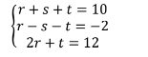
Solve Each system of equations using substitution

